**Task 3**

**Project: Event Management System**

**1.Database and Data Table Creation**

**DB Creation**

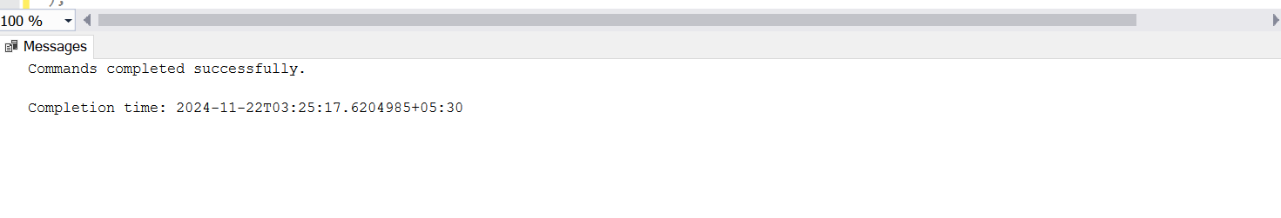

**Table Creation**

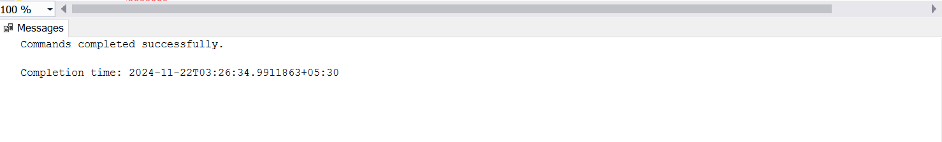

**Events Table:**

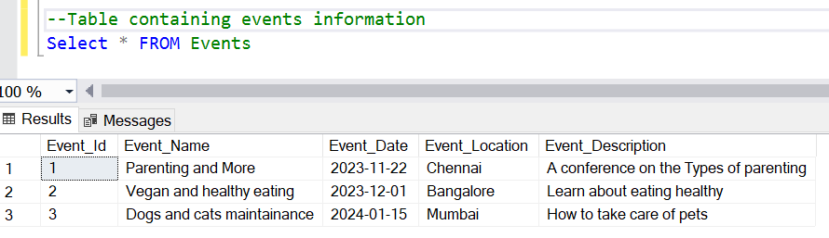

**Table Containing events in Chennai alone:**

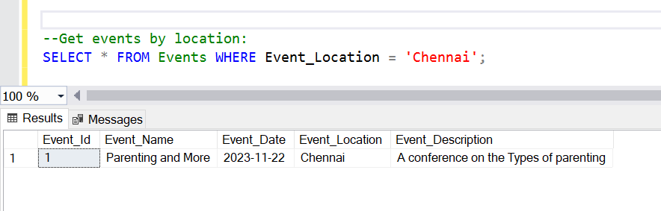  
**Attendees Table:**

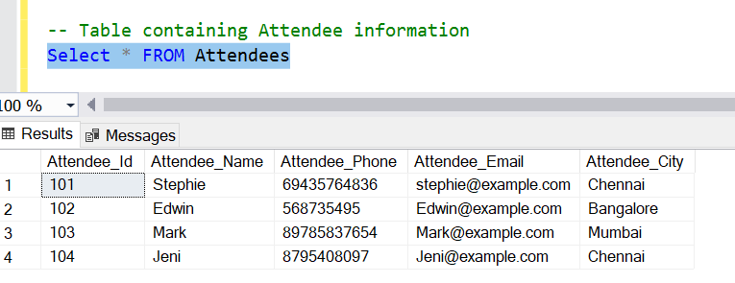

**Registration Table:**

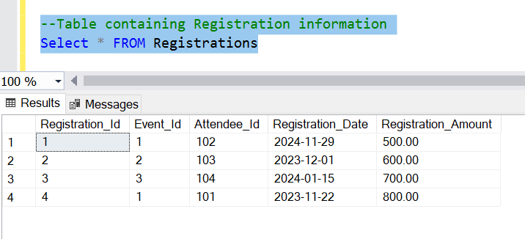

3. **Manage Event Details:**

**a) Inserting a new event:**

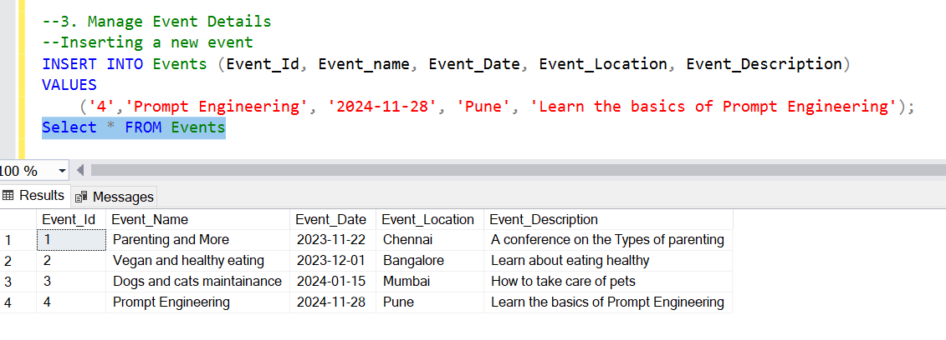

**b) Updating an event's information**

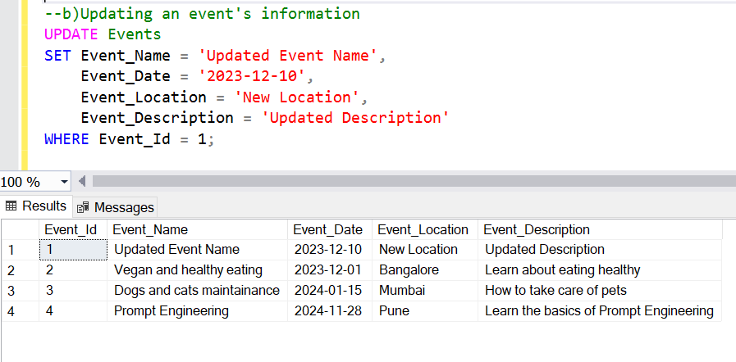

**c) Deleting an event**

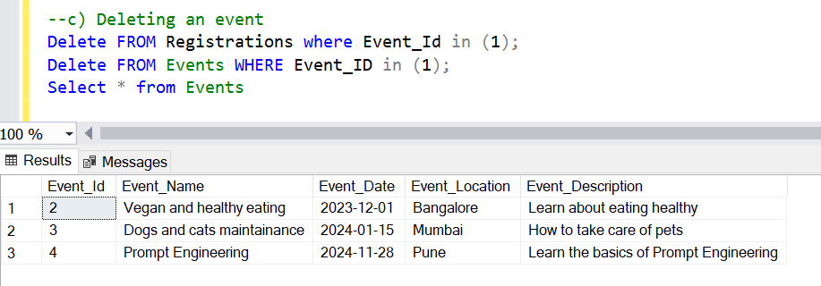

**4) Manage Track Attendees & Handle Events**

**a)Inserting a new attendee**

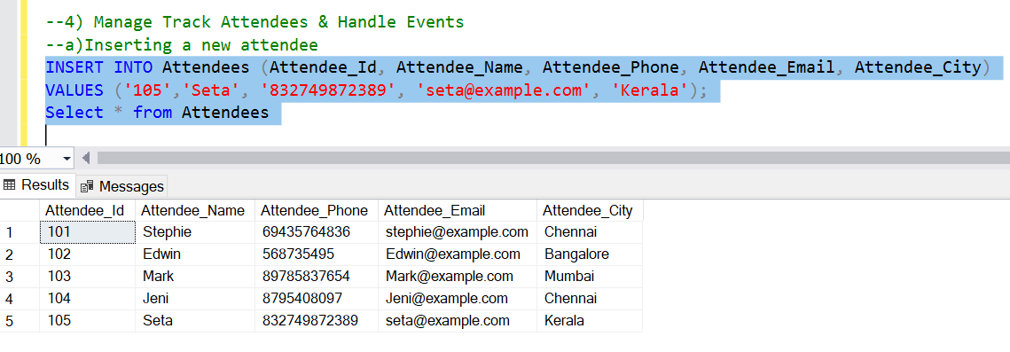

**b)Registering an attendee for an event**

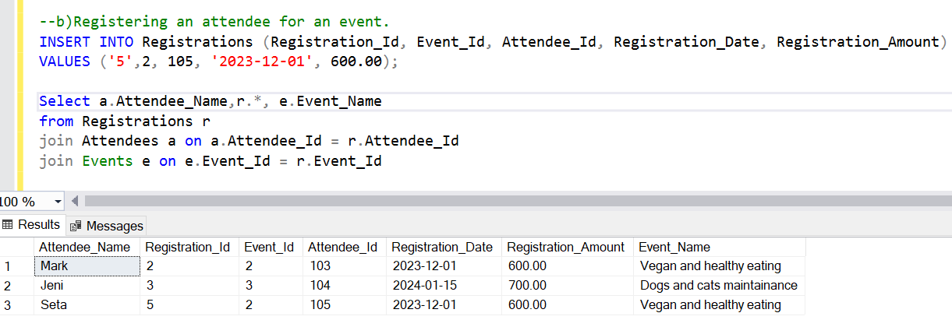

**5.Develop queries to retrieve event information, generate attendee lists, and calculate event**

**attendance statistics.**

Count attendees for an event:

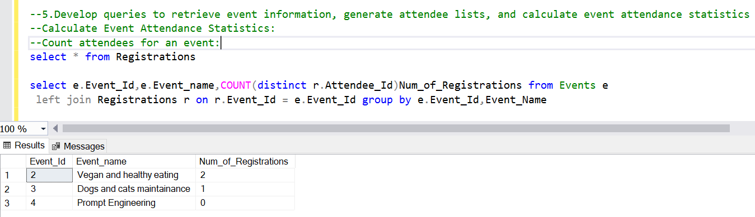

**Total registration amount for an event:**

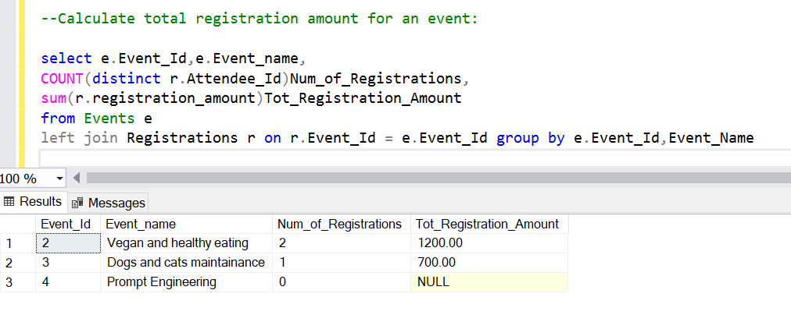

**Average registration amount:**

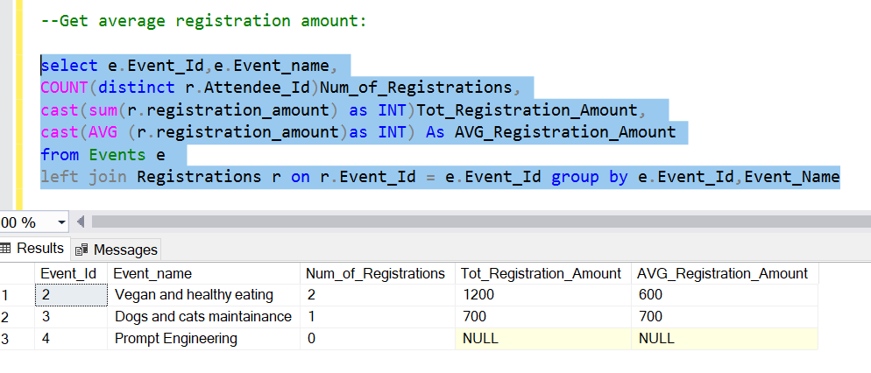

**Attendees Statistics based on City and Event**

